|  |  |
| --- | --- |
| STUDENT NAME | Abdullah Muhammad Ibrahim |
| STUDENT ID | SP20-BSCS-0027 |
| SECTION | AM |
| ASSIGNMENT NO. | 03 |
| DUE DATE | Oct 26, 11:59 PM |
| SUBMITTED ON | Oct 24, 2020 |

Department of Computer Science

Question 1/Task 1:

Using the 2D arrays in java, you are required to calculate the grade of 5 students for 5 courses. For every student, input the marks for each course from keyboard and display the respective earned grade of the student. (Perform necessary calculations)

Hint: Each row of the array represents students, whereas the columns of each row represent the marks of individual courses of that student.

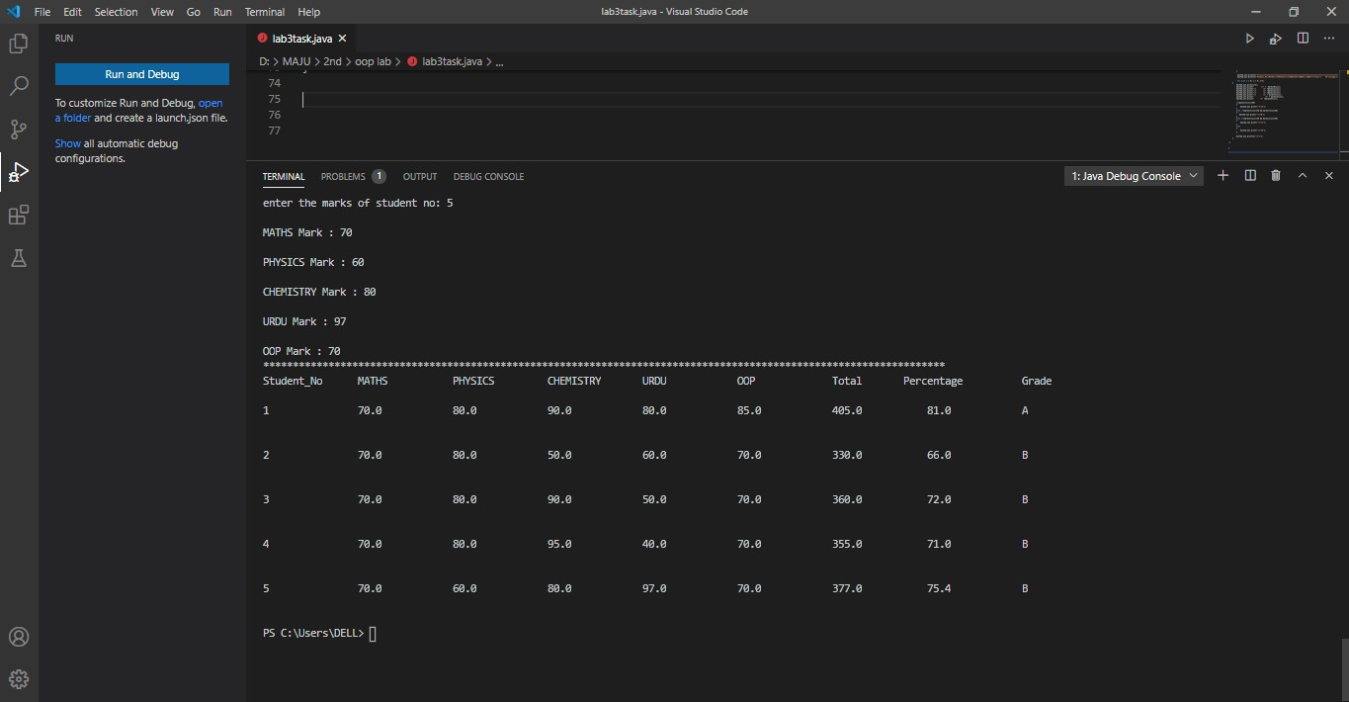

Question 2/Task 2:

Using the command line arguments, you are required to pass 5 numbers and print their sum. (Perform typecasting)

Hint: Partial code is attached for reference.

